* 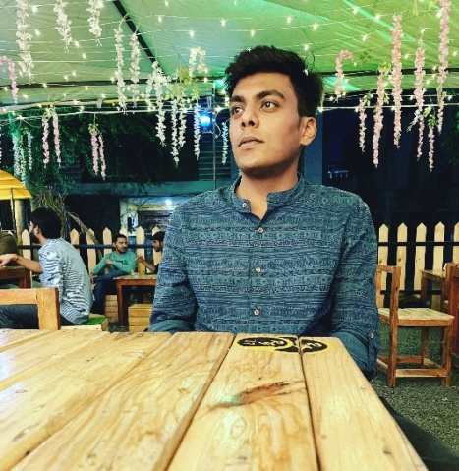

**AKSHAT SHARMA**

***Mob. No- 9171448592***

[sharmaakshat1335@gmail.com](mailto:sharmaakshat1335@gmail.com)

***Indore-(MP)***

**SKILLS: -**

* **Programming languages like, C/C++, Java, basics of python,javascript, Most experienced with Java.**
* **WebDevelopment**
* **Leadership&Management**
* **LogicalReasoning**
* **ProblemSolving**

**EDUCATION: -**

**MEDICAPS UNIVERSITY, INDORE-2023**

**B. TECH COMPUTER SCIENCE**

* **CGPA-7. 08/10**

**H.S.C : 2019**

**SHRINARSINGHPUBLICSCHOOL**

* **PERCENTAGE – 68%**

**OBJECTIVES : -**

**Secure a responsible career to utilize my training and skills and achieve a challenging position in software development in a result- oriented company.**

**RELEVANT COURSEWORK : -**

* **Software Engineering**
* **Design Analysis & Algorithm**
* **Database Management System (DBMS)**
* **Object – oriented programing languages**

**EXPERIENCES : -**

* **Quick Learner, Enjoy learning new skills, Flexible.**
* **Strong communication skills & management skills.**
* **Successful in meeting new challenges.**

**PROJECTS : -**

**STOCK PREDICTION MODEL**

**AMAZON WEB CLONE**

**Website | August 2022 – October 2022**

* **Developed & designed UI**
* **Technologies used : - HTML, CSS, JAVASCRIPT,PYTHON(LSTM)**

**HOBBIES : - Playing Cricket (played regional from my school & nominated for nationals) , Watching Anime, & like to watch Football Matches.**

**CURRICULUMVITAE**